Week Two
(June 6th - June 10th):
Secret Agent: Spy Academy
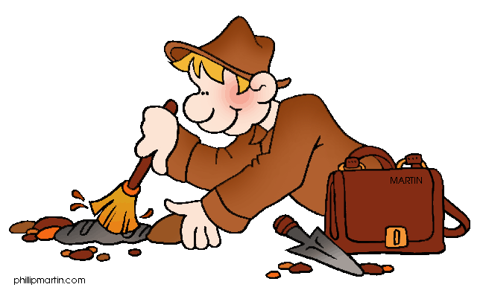
2016 Summer
Camp Blast
Week Three (June 13th – June 17th):
The Little Spielberg
in All of Us
Week Six (July 5th – July 8th):
Whistles, Hoses, and Stethoscopes
Week Nine (July 25th – 29th):
Bronze, Silver, and Gold
Week One (May 31st – June 3rd):
Night at the Museum

Learn the qualities of a good leader.
Experience new and exciting challenges.
Develop critical thinking skills.
Practice effective communication skills.
Receive constructive feedback.
Build confidence.
HAVE FUN!

Grab a Camp Blast Registration Packet to Sign Up!
or Sign Up For Our Camp Blast
Leaders in Training Program
For Rising 7th-12th Grade Students

Week Five (June 27th - – July 1st): Astronauts Reporting to NASA

Week Four (June 20th – 24th):
Let’s Have a Hay Day!

Week Eight (July 18th – 22nd):
Minecraft and Games Galore!
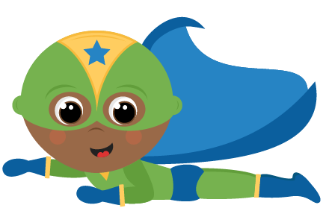
Week Seven (July 11th - –July 15th):
Bam! Kapow! Shazam!
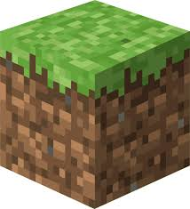

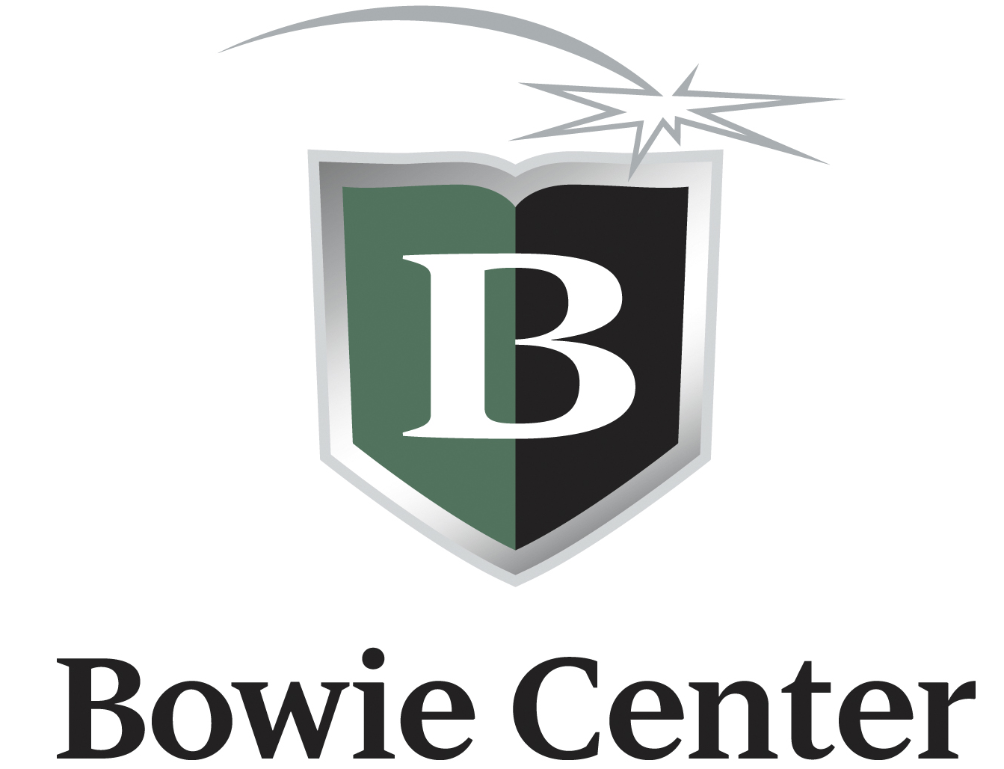
SUMMER 2016 CAMP BLAST

The Bowie Center is proud to bring to you CAMP BLAST! This is a camp for students who want to have a fun summer filled with daily activities that incorporate fun and play with learning and creating. Building upon weekly themes, we will continually have something new in store for our campers. Our campers may be between the ages of 4-12 and our LIT’s (leaders in training) need to be at least 13 years of age.

Camp Blast Sessions and Special Weekly Themes:
Week 1 | May 31st – June 3rd (4 day week) | Night at the Museum
Week 2 | June 6th – 10th | Secret Agent: Spy Academy
Week 3 | June 13th – 17th | The Little Spielberg in All of Us
Week 4 | June 20th – 24th | Let’s Have a Hay Day!
Week 5 | June 27th – July 1st | Astronauts Reporting to NASA
Week 6 | July 5th – 8th (4 day week) | Whistles, Hoses, and Stethoscopes
Week 7 | July 11th – 15th | Bam! Kapow! Shazam!
Week 8 | July 18th – 22nd | Minecraft and Games Galore!
Week 9 | July 25th – 29th | Bronze, Silver, and Gold

Registration: All students between the ages of 4-12 may apply to be a camper. Students 13 and up may apply to be an LIT (Leader In Training). Students will be registered on a first-come first-serve basis. A student is not registered until all forms and payments have been received. We will email a confirmation to you once your application has been processed. Forms and payments may be brought directly to the center, scanned and emailed (if using a credit card) to tutoring@bowiereading.com or mailed to: Bowie Camp Blast, 2550 Ridgeway Road, Memphis, TN 38119.

Camp Blast Hours: Camp Blast is open daily from 9:00am-3:00pm Monday-Friday. Our half day camp options are 9:00am-12:00pm or 1:00pm-3:00pm. The Bowie Center will close Monday, May 30th and Monday, July 4th.

Early Risers: Camp Blast Campers may come as early as 7:30 am each day. Campers are welcome to bring their breakfast each morning if they wish. We will have open playtime from 7:30 -9:00 am before camp begins. Early Riser sessions are $25 each week (or $20 for Week 1&6). Campers must be registered and fees paid by the Friday prior to the next week’s sessions for Early Risers.

Late Owls: Camp Blast will remain open after hours from 3:00–6:00 pm each day. This will be supervised open playtime. The cost for Late Owls is $60 per week (or $50 for weeks 1&6). Campers must be registered and fees paid by the Friday prior to the next week’s sessions for Late Owls.

Drop In Campers: Campers may register on a “drop in” basis for $60 a full day or $45 a half day.

Drop Off, Pick-up and Supervision: Students should arrive on time and be picked up at the end of each registered session. Camp Blast’s doors open each day at 7:30am for our Early Risers and 8:45am for all campers. Students may not be dropped off before that time. Any student arriving prior to 8:45 am will be sent to Early Risers and charged $5.00 for that day. Camp Blast ends at 3:00 each day. Any student not picked up by 3:15 will be sent to Late Owls and will be charged $12. Late Owls ends at 6:00 pm each day. Should a student not be picked up by 6:00 pm, his/her account will be charged $5.00 for each additional minute.

Attendance: Cancellations for Camp Blast may be made up to 7 days prior to a registered Camp Blast week. Refunds will not be given for a student who chooses to not attend a session or activity after this time. The Bowie Center will not contact parents when a student is not in attendance for a Camp Blast day.

Tutoring during Camp Blast Hours: Students who enroll for tutoring or academic workshops at the Bowie Center during Camp Blast Hours, will receive a discount of $5 for each hour they miss Camp during these sessions.

LIT (Leaders In Training): For Rising 7th-12th grade Students
LIT campers may register for a one or multi-week experience.
As an LIT, students will learn how to be a leader at school or in the community. LIT campers will have the opportunity to develop skills of responsibility, organization and creativity. LIT’s will work along side our counselors each week as we provide tailored lessons to help each student develop confidence and leadership skills. Our goals will be for each LIT camper to:
- Learn the qualities of a good leader.
- Experience new and exciting challenges.
- Develop critical thinking skills.
- Practice effective communication skills.
- Receive constructive feedback.
- Build his/her confidence.
- HAVE FUN!
Discounts: Multi-Session Discount: Families may take advantage of the multi-session discount by registering for four or more weeks by May 6th. Both registration forms and payments must be in by May 6th to receive this discounted price.
* The half day option does not apply to this discount.
Multi-Child Discount: Families who enroll more than one child for four or more sessions will receive a discount of $50 off each additional child’s registration fee.

What to bring: Students should wear comfortable clothes for play. Tennis shoes are not required but preferred. The Bowie Center is not responsible for lost or stolen items so please do not send your child with valuables. Each student should bring a beach towel or throw to be used when we sit on the floor. Campers should bring a swimsuit, flip flops or water shoes (a must for the hot pavement) and towel for water play on hot days. All items should be labeled clearly with the camper’s name.

Lunch: Each camper should bring a sack lunch Monday-Thursday. We have plenty of microwaves but not enough refrigeration for lunches. You will need to provide a coolant if you want to keep your child’s lunch cold. Drinks may be purchased at the camp canteen for $0.75. Please make sure your child’s name is on his/her lunch box. Each Friday we will have Fantastic Pizza Friday. The fee for your camper’s pizza and drink is included in the registration fee. If you do not want your child to eat pizza, please send a sack lunch on Fridays as well.

Camp Canteen: The camp canteen will be open each day and will offer snacks and drinks for campers for break times. Each item is $0.75, which includes all drinks such as bottled water, soft drinks and juice boxes, as well as snacks such as chips, cookies, fruit and candy. Campers may choose to have an account in his/her name and withdraw canteen payments as needed. Our canteen will not contain meal type foods so please do not send money for your camper to purchase his/her lunch at the canteen. We do stock “morning type” snack items such as pop tarts, small boxes of cereal and juice, which are available for Early Risers as well as all day.

Blast Field Trips & Special Guests: Adding to the excitement of Camp Blast each week, depending on the theme, we will either go off campus on a field trip or have special guests visit the campers. All field trip fees are included in our registration fees. Bowie uses the cars of our Adult counselors for all field trips. When you register your child in Camp Blast, you are giving permission for your camper to ride, secured in a seatbelt, in a car driven by one of our adult counselors. We do not put campers in the front seats of our cars. Should your camper need a booster seat, please remember to leave this with us at drop off. If you do not wish for your camper to attend any planned field trips, you must not send him/her to camp that day. We cannot leave a camper at the center while we are gone on a field trip.

Mandatory Withdrawal: Each student enrolled at the Bowie Center is expected to behave in an appropriate manner. The Bowie Center reserves the right to dismiss a student whose behavior results in a serious discipline problem. The Bowie Center administration has the authority to make this decision in the best interest of the students and the center. No refunds will be given for a student who is dismissed from any of the Bowie Center’s programs.

Calling all recruits! Have you ever wanted to be a spy? Do you have a talent for figuring out mysteries or keeping a secret? This week is a training academy to learn what it takes to become the number one agent for our elite group of undercover spies. Develop your own unique disguise as you go on undercover operations assuming a different identity. Create and use a variety of spy gadgets such as glasses to watch behind your back. Learn how to break secret codes using math and science. Each day agents will receive top-secret missions that must be completed by the end of the camp day. Recruits who have successfully accomplished the training will earn their very own spy kit.

Come learn about life on a farm. Agriculture will be the focus of this week. We will learn about different vegetables, how they grow, and new ways to prepare them while making delicious dishes. Each day our campers will become “country cooks” as we create wonderful savory foods. We will then turn our attention to animals on a farm and the wonders they bring. We will visit a local farm and see chickens and rabbits, as well as fruits and vegetables. Our week will end with our campers cooking a country breakfast together using homemade butter and syrup on our home cooked pancakes.

Week Two (June 6th – 10th):
Secret Agent: Spy Academy

Week One (May 31st – June 3rd):
Night at the Museum

2016 Summer
Camp Blast
Explore the many types of museums around the world in this week filled with music and art. The Grammy Museum Day will have campers learning about different musicians and genres of music. We may even attempt a dance off. On History Museum Day we will study the wonders of Ancient Egypt as we dig for treasures, form faux clay pots, and create Egyptian scarab jewelry. Art Museum Day will have campers expanding their creativity while painting, drawing, and sculpting individual works of art. This exciting week will include a field trip to the Memphis Children’s Museum.

Week Four (June 20th – 24th):
Let’s Have a Hay Day!

Have you ever wanted to direct your own movie? This is your chance. Campers will work together to write a screenplay to be used in an original camp BLAST movie! We will scout out a perfect setting for each scene. Learning about special sound effects will help make our story come to life. Campers will design and build the props for our production set. On Friday we will watch our film together in a “real” movie theater setting. Our film will also be made available to each camper’s family. In addition to creating our own film, we hope to attend a movie during the week at the Malco Theater’s summer movie program for kids.

Week Three (June 13th – 17th):
The Little Spielberg in All of Us

.
Week Nine (July 25th – 29th):
Olympics
The Bowie Olympic Week will get these campers in the spirit for the official 2016 World Games. In this action packed week, campers will learn about the different games such as track and field, archery, gymnastics, and many more Olympic sports. In addition to sports, we will also explore and learn about the cultures of some of the different Olympic countries. Make your own drums and study their significance in many of the African cultures. Learn about the Maori of New Zealand as we create Koru Art using chalk pastels. We will learn about the 5 rings and study the flags of many countries. Keeping in the Olympic spirit, we’ll be “training” and building an obstacle course all during the week.
The Bowie Games will end our summer, complete with a platform and medal ceremony.

To infinity and beyond! Come explore the world above! We will take our minds on a journey around the solar system, exploring many different features of space. In our science lab we’ll be identifying constellations and creating star charts and telescopes. We’ll map out the terrain of the moon and lunar craters. Come help us make a paper-mache solar system. Each camper will get to create a unique planet in our science fiction outer space. Do you think we’ll ever go to Mars? It will be fun to discuss the possibilities and see what scientists have discovered about this planet. A highlight of this week will be a trip to the Pink Palace Planetarium.

Do you like Minecraft? Super Mario Brother? Zelda? Tetris? Battleship? If you love games, then this week was created for you! Each day we will add on new games as we turn our camp into a Bowie Arcade. Fight off creepers who try to sneak into our camp. Campers will play a life-size version of Tetris as we learn about shapes and spatial relations. Save Zelda as Link takes on several different tasks to advance forward and rescue her from danger. The Bowie Gaming station will be set-up to play some of our favorites as we have our own daily tournaments. Sign up for this EPIC gaming week!

Week Five (27th-July 1st):
Astronauts Reporting to NASA

Week Seven (July 11th - 15th):
Bam! Kapow! Shazam!

Week Eight (July 18th – 22nd):
Minecraft and Games Galore!

Come learn about real life superheroes who save the world every day in your community. Firemen and Police Officers will be our special guests this week as we learn about how they protect and help our city. Each day will be filled with various activities, as we explore their careers and learn what it takes to be a real-life superhero. Learn about fire safety, as we visit the local Fire Museum. Learning from our police force, we will investigate a “crime scene” and put together the clues to uncover the mystery. We will create our own courtroom, as we embark on a “court case” while campers become the lawyers, the judge, and the jury to help us solve the case. The suspense will build as our camper policemen present evidence from the investigation.

Week Six (July 5th – 8th): No Camp Monday July 4th
Whistles, Hoses, and Stethoscopes
Bringing the comics to life right before your eyes. We will explore various worlds as we read a variety of action packed comic book stories. Go on adventures as heroes in Stan Lee’s X-Men series or be a citizen in Gotham city where Batman is trying to save the city from corrupt villains. Each camper will morph into a unique superhero during the week. Our camp will truly come to comic book life. As the excitement of this week builds, one never knows who might drop in at this camp. Campers should be on the lookout to meet some of their favorite stars, such as Batman and Captain America. At the end of the week, students will have their own comic book to take home and share with their family and friends.

2016 Summer Camp Blast Registration Form
Student’s Name: |  |  |  |  |  |  |  |  |  | Gender: |  |  |  |  | Date of Birth:
School: |  |  |  |  |  | Age: |  |  |  |  | Grade (2016-2017 School Year):
Student’s Address: |  | Street:
 |  | City: |  |  |  |  |  |  | State: |  |  |  |  |  |  |  | ZIP:
Parent Name: |  |  |  |  |  |  |  |  | Email:
Parent Name (2):  If Applicable |  |  |  |  |  |  |  |  | Email:
Phone Numbers: |  |  |  | 1. ( )- - |  |  | Work Mobile Home |  |  |  |  |  |  |  |  | for
Please provide at least 2 |  |  |  | 2. ( )- - |  |  | Work Mobile Home |  |  |  |  |  |  |  |  | for
 |  |  |  | 3. ( )- - |  |  | Work Mobile Home |  |  |  |  |  |  |  |  | for

EMERGENCY INFORMATION:
Emergency Contact (other than parent): |  |  |  |  |  |  | Relationship:
Phone Number (where Emergency contact can be reached during camp hours):
Doctor’s Name: |  |  |  |  |  | Phone:
Does your child need specific medication, an inhaler or Epipen in case of an emergency? |  |  |  |  |  |  |  |  |  | Yes No
If so please explain:
All medications must be delivered to the camp director labeled with instructions included in a zip lock bag!
Please list any allergies, dietary or physical restrictions or anything we should know about your child’s health:
Please list anyone other than the names listed above who has permission to pick up your child:
Name: |  |  |  |  |  | Phone:
Name: |  |  |  |  |  | Phone:

Your registration fee includes a camp T-shirt. Please indicate your child’s T-shirt size:
Youth XS | Youth S | Youth M | Youth L | Adult S | Adult M | Adult L | Adult XL

How did you hear about Bowie Summer Camp?

My signature below authorizes the Bowie Center to act on my behalf as an agent for medical or surgical services to be provided to my child in the event of a medical emergency. I hereby release Bowie from any liability which might arise from the giving of such authorization or consent on my behalf, it being my desire that my child be furnished with such medical or surgical treatment as soon as reasonably possible after the need arises.
I agree to release and hold harmless Bowie, its agents, and its employees from all claims, damages, and liabilities for injuries to my student that are not the result of gross negligence by Bowie, its agents, or its employees. I further agree to indemnify Bowie for any damages caused by my student.
I give permission for my child to ride, secured in a seatbelt, in the car of an adult counselor on any Camp Blast field trips. It is my responsibility to provide a booster seat for my child, should one be needed.
I consent to the use, publication, and copyright by Bowie in its publications, brochures, videos, internet web site, and other promotional materials, of photographs in which my child may appear as a student in any programs or activities of Bowie; and the foregoing consent shall extend by my child’s enrollment, and shall survive any termination of this program.

Parent/Guardian Signature: |  | Date:

Camp Blast Registration
Camp Blast Weeks: | Full Day  9am-3pm | Multi-Session Discount  if registered for 4+ weeks by May 6th | Half Day  Multi-session discount does not apply |  |  |  | Early Risers  7:30am-9am | Late Owls  3pm-6pm |  | Totals:
 |  |  | 9am-12pm |  | 12pm-3pm
Week 1 (May 31st- June 3rd) | $180 | $160 | $115 |  | $115 |  | $20 | $50 |  | $
Week 2 (June 6th- 10th) | $220 | $195 | $135 |  | $135 |  | $25 | $60 |  | $
Week 3 (June 13th- 17th) | $220 | $195 | $135 |  | $135 |  | $25 | $60 |  | $
Week 4 (June 20th – 24th) | $220 | $195 | $135 |  | $135 |  | $25 | $60 |  | $
Week 5 (June 27th- July 1st) | $220 | $195 | $135 |  | $135 |  | $25 | $60 |  | $
Week 6 (July 5th- 8th) | $180 | $160 | $115 |  | $115 |  | $20 | $50 |  | $
Week 7 (July 11th- 15th) | $220 | $195 | $135 |  | $135 |  | $25 | $60 |  | $
Week 8 (July 18th- 22nd) | $220 | $195 | $135 |  | $135 |  | $25 | $60 |  | $
Week 9 (July 25th- 29th) | $220 | $195 | $135 |  | $135 |  | $25 | $60 |  | $
*Fantastic Pizza Fridays and all Field Trip costs are included in registration fees*  **A minimum deposit of $25.00 per week is due with each application** |  |  |  |  |  |  |  | Subtotal: |  | $
Multi-Child Discount more than one child is registered for four or more sessions |  |  |  |  |  |  |  |  | − $50 = | $
Leaders in Training Discount for rising 7th-12th grade students: |  |  |  |  |  |  |  |  | − $50 = | $
 |  |  |  |  |  |  | Total Balance Due: |  |  | $
Drop-In Registration-
Campers registered on a drop-in basis, may attend camp on select days. We require a 24-hour notice to schedule these sessions. A full day drop-in session is $60 and a half-day is $45.

**Campers who are also tutoring will receive $5 off of their weekly Camp Blast balance for each hour they miss of camp**
due to tutoring sessions. The Bowie Staff will make this price adjustment at the time of registration if applicable.
I have enclosed a cash payment of |  |  |  | $ |  |  |  | .
I have enclosed a check for |  |  | $ |  |  |  | made payable to The Bowie Center.
I would like for you to run my credit card for |  |  |  |  |  | $
 | Name on the Card: |  |  |  |  |  |  |  |  | Card Type:
 | Card Number:
 |  | Expiration Date: |  |  |  |  |  |  | Security Code:
 | Signature:

For Office Use Only:
Amount Due: $ |  | Amount Received: $ |  | Remaining Balance: $

