2017 Summer
Camp Blast
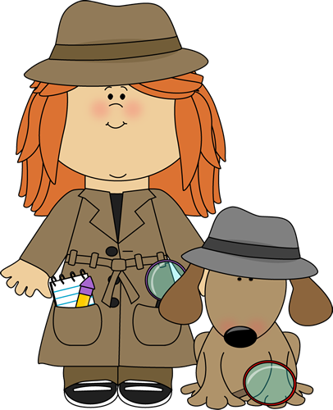
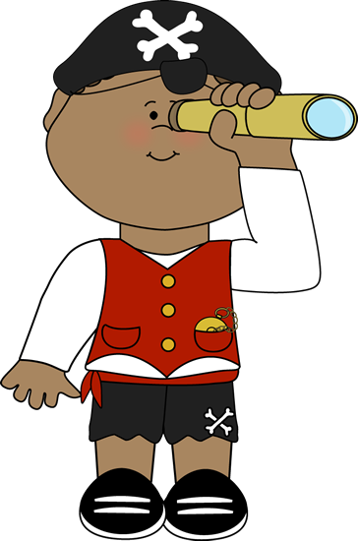
Week Two (June 5th - June 9th):
Secret Agent: Spy Academy
Week One (May 30th– June 2nd):
Mermaids and Pirates

or Sign Up For Our Camp Blast
Leaders in Training Program
For Rising 7th-12th Grade Students
Week Three (June 12th – June 16th):
Master Chef Jr.

Week Five (June 26th – June 30th):
Superhero Week

Week Six (July 5th – July 7th):
Stars and Stripes Forever
Week Four (June 19th – 23rd):
Animal Planet

Week Eight (July 17th – 21st):
Around the World in 5 Days

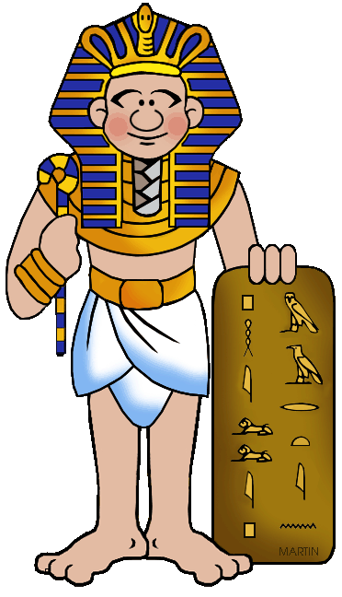
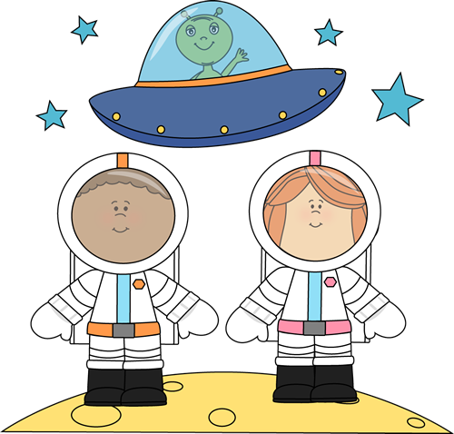
Week Ten (July 31st– Aug. 4th):
It’s A Bug’s Life

Week Nine (July 24th – 28th):
Night at the Museum

Learn the qualities of a good leader.
Experience new and exciting challenges.
Develop critical thinking skills.
Practice effective communication skills.
Receive constructive feedback.
Build confidence.
HAVE FUN!

Grab a Camp Blast Registration Packet to Sign Up!
Week Seven (July 10th –July 14th):
Space is the Place

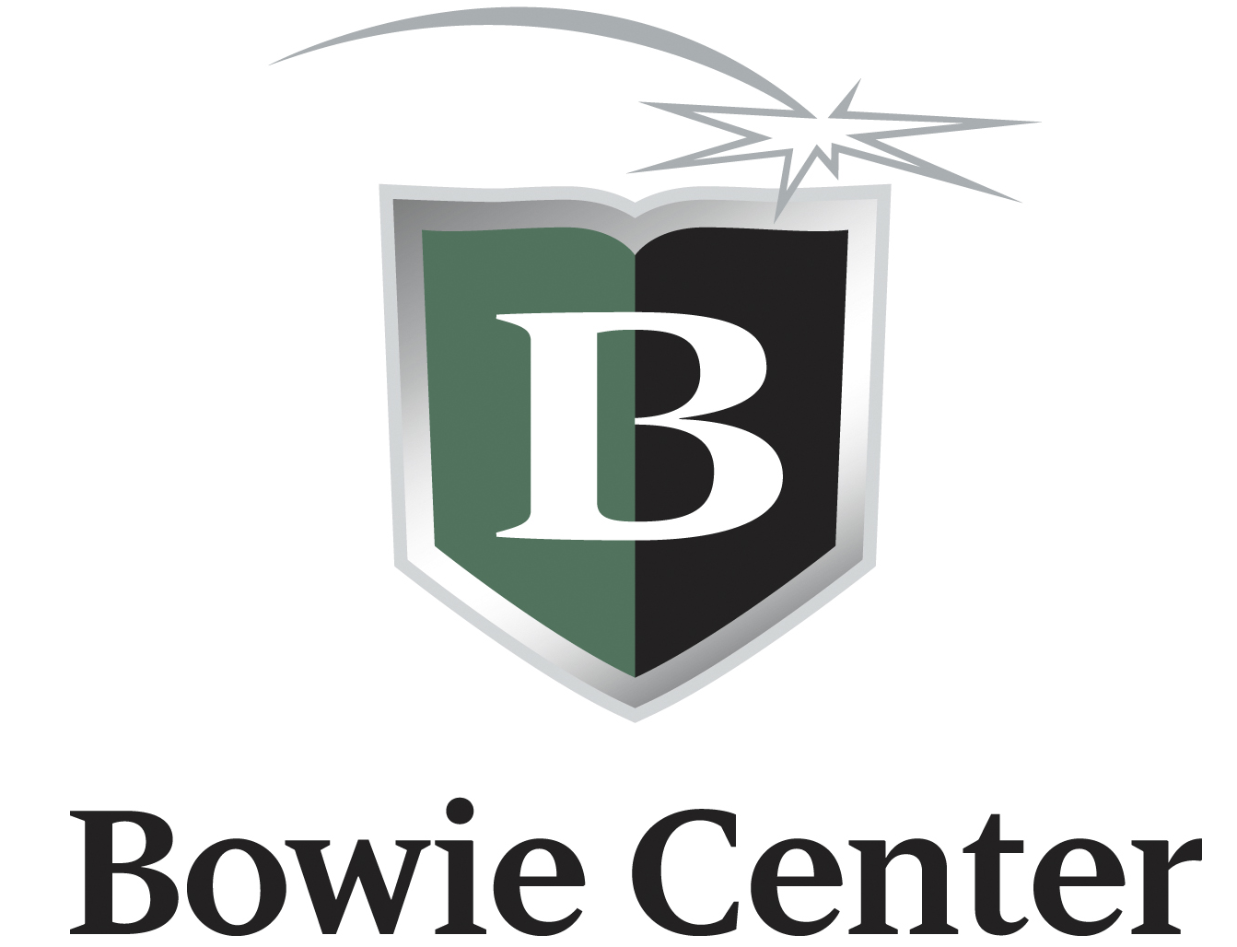
SUMMER 2017 CAMP BLAST

The Bowie Center is proud to bring to you CAMP BLAST! This is a camp for students who want to have a fun summer filled with daily activities that incorporate fun and play with learning and creating. Building upon weekly themes, we will continually have something new in store for our campers. Our campers may be between the ages of 4-12 and our LIT’s (leaders in training) need to be at least 13 years of age.
Camp Blast Sessions and Special Weekly Themes:
Week 1 | May 30th – June 2nd (4 day week) | Mermaids and Pirates
Week 2 | June 5th – 9th | Secret Agent: Spy Academy
Week 3 | June 12th – 16th | Master Chef Jr.
Week 4 | June 19th – 23rd | Animal Planet
Week 5 | June 26th – 30th | Superhero Week
Week 6 | July 5th – 7th (3 day week) | Stars and Stripes Forever
Week 7 | July 10th – 14th | Space is the Place
Week 8 | July 17th – 21st | Around the World in 5 Days
Week 9 | July 24th – 28th | Night at the Museum: The Ancient World
Week 10 | July 31st – Aug 4th | It’s A Bug’s Life

Registration: All students between the ages of 4-12 may apply to be a camper. Students 13 and up may apply to be an LIT (Leader In Training). Students will be registered on a first-come first-serve basis. A student is not registered until all forms and payments have been received. We will email a confirmation to you once your application has been processed. Forms and payments may be brought directly to the center, scanned and emailed (if using a credit card) to tutoring@bowiereading.com or mailed to: Bowie Camp Blast, 2550 Ridgeway Road, Memphis, TN 38119.

Camp Blast Hours: Camp Blast is open daily from 9:00am-3:00pm Monday-Friday. Our half day camp options are 9:00am-12:00pm or 1:00pm-3:00pm. The Bowie Center will close May 29th, July 3rd, and July 4th.

Early Risers: Camp Blast Campers may come as early as 7:30 am each day. Campers are welcome to bring their breakfast each morning if they wish. We will have open playtime from 7:30 -9:00 am before camp begins. Early Riser sessions are $25 each week ($20 for Week 1 and $15 for Week 6). Campers must be registered and fees paid by the Friday prior to the next week’s sessions for Early Risers.

Late Owls: Camp Blast will remain open after hours from 3:00–6:00 pm each day. This will be supervised open playtime. The cost for Late Owls is $60 per week ($50 for Week 1 and $40 for Week 6). Campers must be registered and fees paid by the Friday prior to the next week’s sessions for Late Owls.

Camp Buddies: Camp BLAST welcomes children with special needs. Camp Buddies are for any child who requires individual support. The cost for Camp Buddies is $60 per week.

Drop In Campers: Campers may register on a “drop in” basis for $60 a full day or $45 a half day.

Drop Off, Pick-up and Supervision: Students should arrive on time and be picked up at the end of each registered session. Camp Blast’s doors open each day at 7:30am for our Early Risers and 8:45am for all campers. Students may not be dropped off before that time. Any student arriving prior to 8:45 am will be sent to Early Risers and charged $5.00 for that day. Camp Blast ends at 3:00 each day. Any student not picked up by 3:15 will be sent to Late Owls and will be charged $12. The Bowie Center closes at 6pm each day. Should a student not be picked up by 6:00 pm, his/her account will be charged $5.00 for each additional minute.

Attendance: Cancellations for Camp Blast may be made up to 7 days prior to a registered Camp Blast week. Refunds will not be given for a student who chooses to not attend a session or activity after this time. The Bowie Center will not contact parents when a student is not in attendance for a Camp Blast day.

Tutoring during Camp Blast Hours: Students who enroll for tutoring or academic workshops at the Bowie Center during Camp Blast Hours, will receive a discount of $5 off each tutoring session during Camp hours.

LIT (Leaders In Training): For Rising 7th-12th grade Students
LIT campers may register for a one or multi-week experience.
As an LIT, students will learn how to be a leader at school or in the community. LIT campers will have the opportunity to develop skills of responsibility, organization and creativity. LIT’s will work along side our counselors each week as we provide tailored lessons to help each student develop confidence and leadership skills. Our goals will be for each LIT camper to:
- Learn the qualities of a good leader.
- Experience new and exciting challenges.
- Develop critical thinking skills.
- Practice effective communication skills.
- Receive constructive feedback.
- Build his/her confidence.
- HAVE FUN!
Discounts: Early Bird Discount: Families may take advantage of the multi-session discounted prices by registering for four or more weeks by May 5th. Both registration forms and payments must be in by May 5th to receive this discounted price.
* The half-day option does not apply to the Early Bird discount.
Multi-Child Discount: Families who enroll more than one child for four or more sessions, will receive a discount of $50 off each additional child’s registration fee.
LIT Discount: LIT’s enrolled in four or more weeks will receive $50 off the registration fee.

What to bring: Students should wear comfortable clothes for play. Tennis shoes are not required but preferred. The Bowie Center is not responsible for lost or stolen items, so please do not send your child with valuables. Each student should bring a beach towel or throw to be used when we sit on the floor. Campers should bring a swimsuit, flip flops or water shoes (a must for the hot pavement) and towel for water play on hot days. All items should be labeled clearly with the camper’s name.

Lunch: Each camper should bring a sack lunch Monday-Thursday. We have plenty of microwaves, but not enough refrigeration for lunches. You will need to provide a coolant if you want to keep your child’s lunch cold. Drinks may be purchased at the camp canteen for $0.75. Please make sure your child’s name is on his/her lunch box. Each Friday we will have Fantastic Pizza Friday. The fee for your camper’s pizza and drink is included in the registration fee. If you do not want your child to eat pizza, please send a sack lunch on Fridays as well.

Camp Canteen: The camp canteen will be open each day, and will offer snacks and drinks for campers for break times. Each item is $0.75, which includes all drinks such as bottled water, soft drinks and juice boxes, as well as snacks such as chips, cookies, fruit and candy. Campers may choose to have an account in his/her name and withdraw canteen payments as needed. Our canteen will not contain meal type foods so please do not send money for your camper to purchase his/her lunch at the canteen. We do stock “morning type” snack items such as pop tarts, small boxes of cereal and juice, which are available for Early Risers as well as all day.

Blast Field Trips & Special Guests: Adding to the excitement of Camp Blast each week, depending on the theme, we will either go off campus on a field trip or have special guests visit the campers. All field trip fees are included in our registration fees. Bowie uses the cars of our Adult counselors for all field trips. When you register your child in Camp Blast, you are giving permission for your camper to ride, secured in a seatbelt, in a car driven by one of our adult counselors. We do not put campers in the front seats of our cars. Should your camper need a booster seat, please remember to leave this with us at drop off. If you do not wish for your camper to attend any planned field trips, you must not send him/her to camp that day. We cannot leave a camper at the center while we are gone on a field trip.

Mandatory Withdrawal: Each student enrolled at the Bowie Center is expected to behave in an appropriate manner. The Bowie Center reserves the right to dismiss a student whose behavior results in a serious discipline problem. The Bowie Center administration has the authority to make this decision in the best interest of the students and the center. No refunds will be given for a student who is dismissed from any of the Bowie Center’s programs.

This is a casting call for all young and aspiring chefs! If you love food, and want to expand your culinary skills, then we’ve whipped up this week just for you! Young chefs will don on aprons and dust off recipes, while learning how to follow directions, measure ingredients, and create delectable treats. We will visit a local farm to see where the very best ingredients are grown. On Friday, we will have the grand opening of the Camp BLAST Café! We will make and serve homemade butter, syrup, and fresh flapjacks for our customers! Bon appetit!

Calling all recruits! Have you ever wanted to be a spy? Do you have a talent for figuring out mysteries or keeping secrets? This week is a training academy to learn what it takes to become the number one agent for our elite group of spies. Develop your own unique disguise as you go on undercover operations. Create and use a variety of spy gadgets. Learn how to break secret codes, using math and science. Sherlock Holmes himself, would be proud of our camp detectives. Each day will be action packed with top-secret missions and mysteries to be solved!

2017 Summer
Camp Blast
Aye, Matey! Arrrre you ready for a week at sea? Start off your summer by taking a dive into the ocean as a mermaid or walking the plank as a pirate. During this week, you’ll explore the secrets of the deep blue sea from above and from below, hunt for buried treasure and dive for sunken ships. Whether you prefer fins and jewels or hooks and gold, be prepared to make your tails and put on your eye patches. Diving into arts and crafts, we will use sand, shells, jewels, and more to create treasures fit for any chest. This week is sure to be a nautical good time!

Week Two (June 5th – 9th):
Secret Agent: Spy Academy

Week One (May 30th – June 2nd):
Mermaids and Pirates

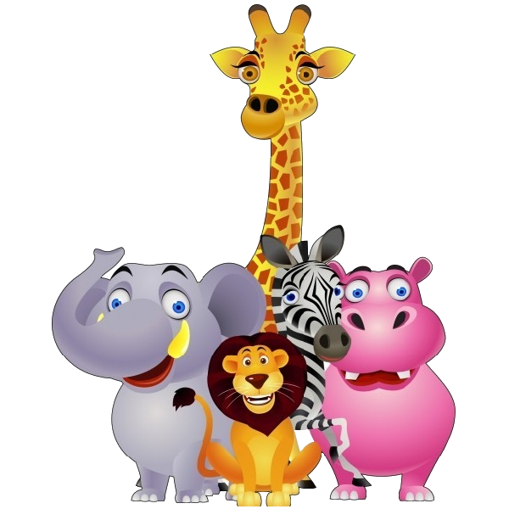
Week Five (26th- 30th):
Superhero Week

We will kick off this ferocious week with Prehistoric Animal Day. Who doesn’t love to learn more about dinosaurs and the world 65+ million years ago? We will then explore the animals of today. We’ll take to the land, sky, and sea as we study the remarkable creatures across the globe, including the arctic tundra, rainforest, jungle, desert, and oceans deep. We will learn about animal habitats and create critter crafts and costumes. We’ll explore our “wild side” as we stomp like elephants, run like cheetahs, and swim like fish. This week may even take us to our very own Memphis Zoo.

Week Four (June 19th – 23rd):
Animal Planet

Week Three (June 12th – 16th):
Master Chef Jr.

Shazam! Bam! Pow! The comic books come to life right before your eyes at Camp BLAST this week! Adventure awaits each camper stepping into Stan Lee’s X-Men series or Batman’s Gotham City. No corrupt villain will get past our superheroes! As the excitement builds, one never knows who might drop in. Campers should be on the lookout to meet some of their favorite heroes, such as Batman, Superman, or Captain America. Campers will morph into a unique superhero of their own making. Whether making capes, shields, masks, or comic books, this is a week for Super campers!

.
Week Six (July 3rd – 7th): No Camp July 3rd or 4th
Stars and Stripes
Week Seven (July 10th – 14th):
Space is the Place
Although this may be a short week of camp, it will be packed full of Red, White, and Blue adventures! Join us for lessons in American history and game activities: as we play Revolutionary War Capture-the-Flag and our own splashy version of the Gold Rush. Who knows, we may even organize our own campaigns for president or march for Uncle Sam. All winners here! Ending out week, what could be more All-American than to include baking apple pies from scratch and making delicious homemade ice cream? Come join us for this Yankee doodle dandy week!

To infinity and beyond! Come explore the world above! Let us take you on a journey around the solar system and explore many different features of space. Could there be life on other planets? It will be out of this world fun when we have Space Alien Day! The campers will enjoy our science lab, as we identify constellations, create star charts, and make telescopes and rockets. Come help us make a paper-mache solar system! In our technology center, we’ll learn about what it takes to be a NASA astronaut. A highlight of this stellar week will be a trip to the Pink Palace Planetarium.

Week Nine (July 24th – 28th):
Night at the Museum

Week Eight (July 17th – 21st):
Around the World in 5 Days

Calling all historians and archeologists! Come with us to explore the earliest civilizations of the world during this week filled with history and activities of the past. As campers discover the worlds of the Egyptians, Mayans, Greeks, and Romans, they will learn about ancient languages, practices, mythology, and art. Throughout this week, campers will translate hieroglyphs, walk like the Egyptians, make sundials like the Mayans, write myths like the Greeks, and adorn themselves as the Romans. This exciting week may also take us to the University of Memphis for a visit to its Ancient Egyptian Collection. http://www.memphis.edu/egypt/exhibit/index.php

Week Ten (July 31st – August 4th):
It’s A Bug’s Life

Whether you love bugs or they bug you, this week’s exploration of the insects that inhabit our world is sure to be one that sticks with you. You’ll get tangled making a web of new friends and flying through bug activities. We’ll play buggy games such as Bug Bingo and explore these small creatures around campus. We may get a bit messy making creepy-crawly treats and creating out own unique insects. Bee prepared to get your hands dirty and anticipate a great week because we’re going to dig in! No doubt, this week won’t be a stinger!

The world may be a pretty big place, but we have 5 days to explore it during this week of camp. As we journey around the world, we will experience different countries and cultures by learning traditional dances, listening to international music, and even cooking specialty foods. Before our travels begin, we’ll make our very own passports to keep track of our trips. Then buckle your seat belts, as it’s off to England, Italy, Japan, India, and Australia. We’ll collect souvenirs from each country along the way. When our expedition ends, we’ll pack up our bags as our world travelers return to Bowie.

2017 Summer Camp Blast Registration Form
Student’s Name: |  |  |  |  |  |  |  |  |  | Gender: |  |  |  |  | Date of Birth:
School: |  |  |  |  |  | Age: |  |  |  |  | Grade (2017-2018 School Year):
Student’s Address: |  | Street:
 |  | City: |  |  |  |  |  |  | State: |  |  |  |  |  |  |  | ZIP:
Parent Name: |  |  |  |  |  |  |  |  | Email:
Parent Name (2):  If Applicable |  |  |  |  |  |  |  |  | Email:
Phone Numbers: |  |  |  | 1. ( )- - |  |  | Work Mobile Home |  |  |  |  |  |  |  |  | for
Please provide at least 2 |  |  |  | 2. ( )- - |  |  | Work Mobile Home |  |  |  |  |  |  |  |  | for
 |  |  |  | 3. ( )- - |  |  | Work Mobile Home |  |  |  |  |  |  |  |  | for

EMERGENCY INFORMATION:
Emergency Contact (other than parent): |  |  |  |  |  |  | Relationship:
Phone Number (where Emergency contact can be reached during camp hours):
Doctor’s Name: |  |  |  |  |  | Phone:
Does your child need specific medication, an inhaler or Epipen in case of an emergency? |  |  |  |  |  |  |  |  |  | Yes No
If so please explain:
All medications must be delivered to the camp director labeled with instructions included in a zip lock bag!
Please list any allergies, dietary or physical restrictions or anything we should know about your child’s health:
Please list anyone other than the names listed above who has permission to pick up your child:
Name: |  |  |  |  |  | Phone:
Name: |  |  |  |  |  | Phone:

Your registration fee includes a camp T-shirt. Please indicate your child’s T-shirt size:
Youth XS | Youth S | Youth M | Youth L | Adult S | Adult M | Adult L | Adult XL

How did you hear about Bowie Summer Camp?

My signature below authorizes the Bowie Center to act on my behalf as an agent for medical or surgical services to be provided to my child in the event of a medical emergency. I hereby release Bowie from any liability which might arise from the giving of such authorization or consent on my behalf, it being my desire that my child be furnished with such medical or surgical treatment as soon as reasonably possible after the need arises.
I agree to release and hold harmless Bowie, its agents, and its employees from all claims, damages, and liabilities for injuries to my student that are not the result of gross negligence by Bowie, its agents, or its employees. I further agree to indemnify Bowie for any damages caused by my student.
I give permission for my child to ride, secured in a seatbelt, in the car of an adult counselor on any Camp Blast field trips. It is my responsibility to provide a booster seat for my child, should one be needed.
I consent to the use, publication, and copyright by Bowie in its publications, brochures, videos, internet web site, and other promotional materials, of photographs in which my child may appear as a student in any programs or activities of Bowie; and the foregoing consent shall extend by my child’s enrollment, and shall survive any termination of this program.

Parent/Guardian Signature: |  | Date:

Camp Blast Registration
Camp Blast Weeks: | Full Day  9am-3pm | Early Bird  Discount  if registered for 4+ weeks by May 5th | Half Day  (Multi-session discount does not apply) |  |  | Early Risers  7:30am-9am | Late Owls  3pm-6pm | Totals:
 |  |  | 9am-12pm | 12pm-3pm
Week 1 (May 30th- June 2nd)* | $180 | $160 | $120 | $120 |  | $20 | $50 | $
Week 2 (June 5th- 9th) | $225 | $200 | $150 | $150 |  | $25 | $60 | $
Week 3 (June 12th- 16th) | $225 | $200 | $150 | $150 |  | $25 | $60 | $
Week 4 (June 19th – 23rd) | $225 | $200 | $150 | $150 |  | $25 | $60 | $
Week 5 (June 26th- 30th) | $225 | $200 | $150 | $150 |  | $25 | $60 | $
Week 6 (July 5th- 7th)* | $135 | $120 | $90 | $90 |  | $15 | $40 | $
Week 7 (July 10th- 14th) | $225 | $200 | $150 | $150 |  | $25 | $60 | $
Week 8 (July 17th- 21st) | $225 | $200 | $150 | $150 |  | $25 | $60 | $
Week 9 (July 24th- 28th) | $225 | $200 | $150 | $150 |  | $25 | $60 | $
Week 10 (July 31st- Aug 4th) | $225 | $200 | $150 | $150 |  | $25 | $60 | $
*Short weeks: Week 1- four days, Week 6- three days  Fantastic Pizza Fridays and all Field Trip costs are included in registration fees  A minimum deposit of $25.00 per week is due with each application |  |  |  |  |  |  | Subtotal: | $
Multi-Child Discount (more than one child is registered for four or more sessions): |  |  |  |  |  |  | − $50 = | $
Leaders in Training Discount (rising 7th-12th grade students enrolled in four or more sessions): |  |  |  |  |  |  | − $50 = | $
Camp Buddies (students needing individual support- see camp info): |  |  |  |  |  |  | + $60 =  (per week) | $
 |  |  |  |  | Total Balance Due: |  |  | $
Drop-In Registration-
Campers registered on a drop-in basis, may attend camp on select days. We require a 24-hour notice to schedule these sessions. A full day drop-in session is $60 and a half-day is $45.

Campers who are also tutoring will receive $5 off of each tutoring session during camp hours.
The Bowie Staff will make this price adjustment at the end of each week.
I have enclosed a cash payment of |  |  |  | $ |  |  |  | .
I have enclosed a check for |  |  | $ |  |  |  | made payable to The Bowie Center.
I would like for you to run my credit card for |  |  |  |  |  | $
 | Name on the Card: |  |  |  |  |  |  |  |  | Card Type:
 | Card Number:
 |  | Expiration Date: |  |  |  |  |  |  | Security Code:
 | Signature:

For Office Use Only:
Amount Due: $ |  | Amount Received: $ |  | Remaining Balance: $

